Header files:  
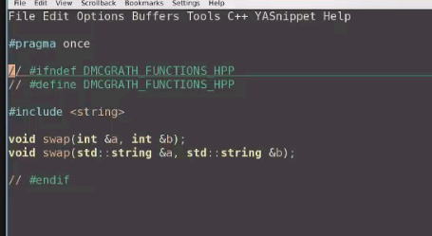

File that defines all function: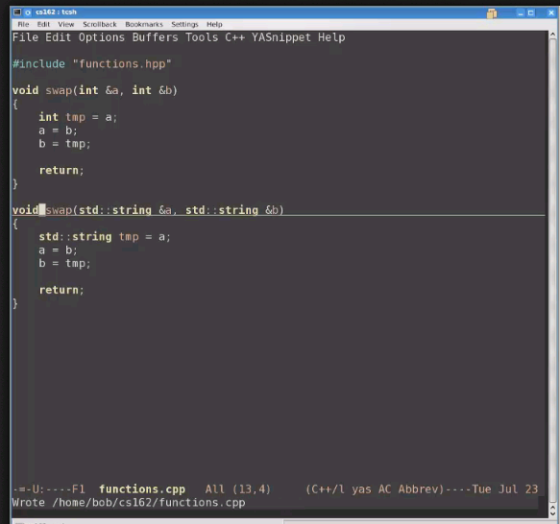

Implementation file

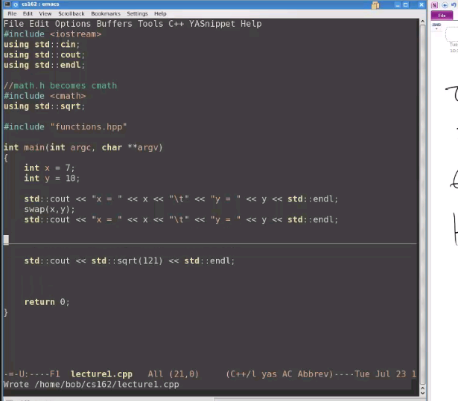

Compilation:

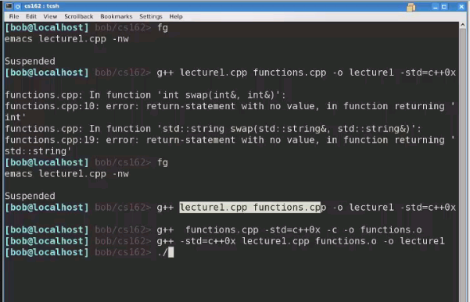

Log into flip

**ssh <username>@access.engr.oregonstate.edu** at the prompt.

Makefiles:

To create makefile type emacs makefile –nw

CXX = g++

CXXFLAGS = -std=c++0x

LDFLAGS = -pthread //anything that we want to include?? What????

Two ways to specify the variables: with the “=”- scans the whole file

Another way to specify the variabel

#target: dependencies

# rule to build

#

//default: lecture1.cpp functions.hpp functions.cpp

Lecture1: lecture1.cpp functions.hpp functions.cpp

g++ -std=c++0x lecture1.cpp functions.cpp –o lecture1

to get back to the next screen

to run it, you just type make

to look at the contents of the folder ls nameof the folder

type fg – not sure what that is

makefile:

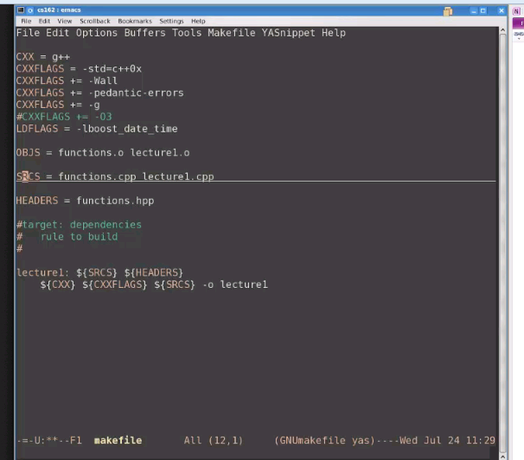

Go to the main screen:

Type make

Type touch lecture1.cpp

make

[Danny Mejia](https://piazza.com/class/hux8wmp35ta6d9?cid=13) [3 days ago](https://piazza.com/class/hux8wmp35ta6d9?cid=13)

Thanks Eric your link helped me out. I had the same issue trying to exit the emacs makefile.   
I used Ctrl x and Ctrl s to save then Ctrl z to exit. That seemed to work for me.

